1.
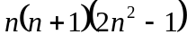

2.
(ii) 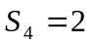
(iii) 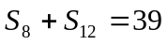 , 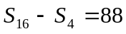

3.
(i) 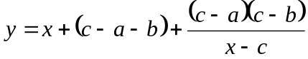
(ii) 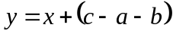 and
(iii) local minimum point : 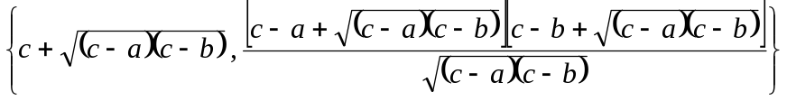, local maximum point : 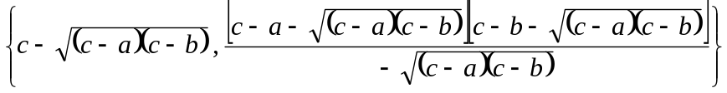
(iv) 